**Transient analysis of RLC Circuit**

**OBJECTIVES:**

* + - * RLC Circuit
      * Pspice
      * RLC Circuit using PSPICE

**RLC Circuit:**

A RLC circuit (also known as a resonant circuit, tuned circuit, or LCR circuit) is an electrical circuit consisting of a resistor (R), an inductor (L), and a capacitor (C), connected in series or in parallel. This configuration forms a harmonic oscillator

.As all the three elements are connected in series so, the current flowing in each element of the circuit will be same as the total current I flowing in the circuit.

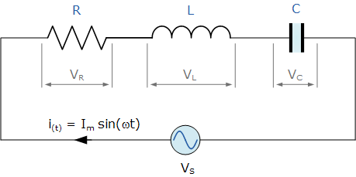

CIRUIT DIAGRAM

**pspice:-**

The circuit file contains different functions which makes the work of an engineer more easy. One can put any sort of symbol using this software and can make different types of circuit diagrams

**RLC Circuit using PSPICE:**

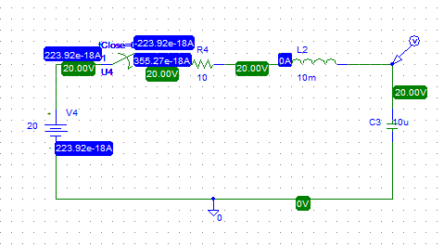

**STEPS:**

* For capacitor use “C”and for inductor use “L”
* For switch we use “sw-tclose”
* y.PNGfor voltage maker
* Select “analysis” from menu bar
* In analysis select “setup”.
* In setup.check “transient”button.
* Click transient button
* Pop window will appear
* Check skip initial transient solution and then click “ok”
* Then, simulate graph will appear
* In graph window, there is trace button
* Click on “Add trace”
* Click on I(LCi) Graph:

**GRAPH**

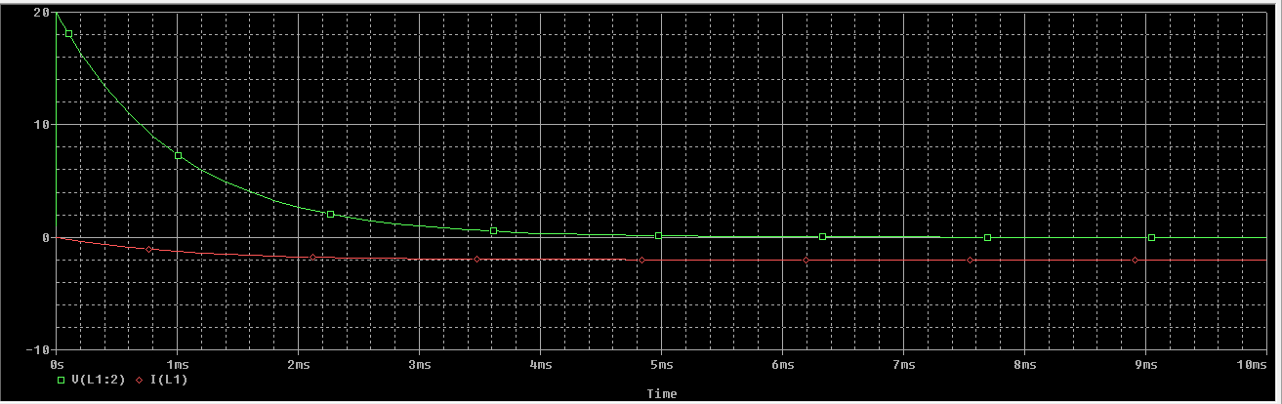

**Conclusion:**

Like the other network *analysis* procedures, we can use RLC to find out the values through a particular element or elements using pspice.